IMPORTANCE OF NAME NODE IN HADOOP CLUSTER:

In Hadoop cluster HDFS consists of one name node and many data nodes.

Name node acts as an master and data node acts as an slaves.

Name node contains details (location, size etc.) about all data nodes and controls and coordinates all the data nodes.

Name node acts as an point of contact to the users.

Name Node is usually configured with a lot of memory (RAM). Because the block locations are help in main memory.

BASIC HDFS COMMANDS:

1.PUT COMMAND:

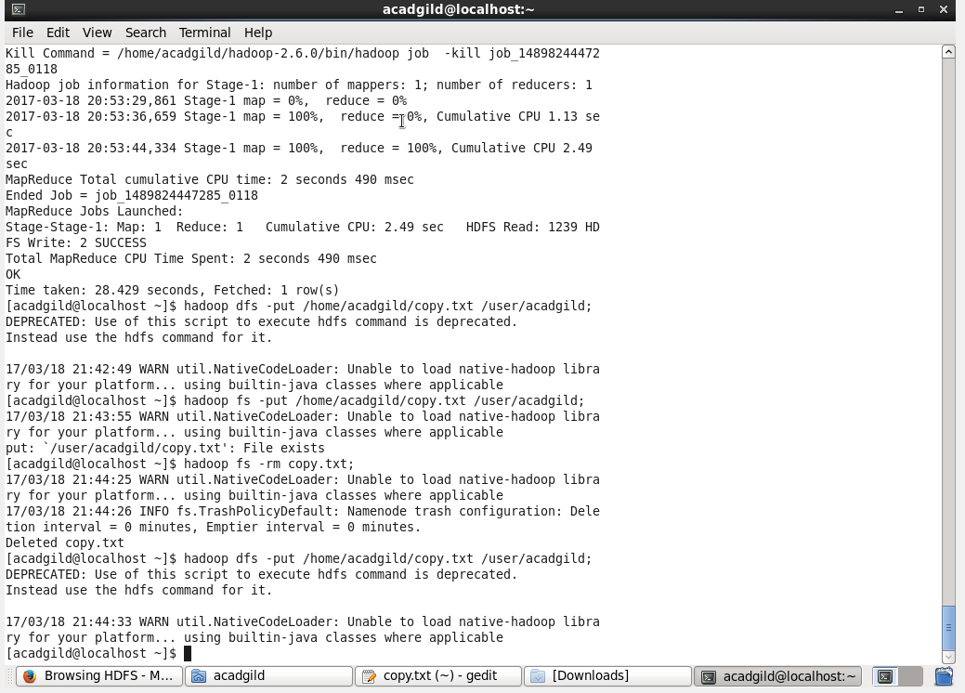

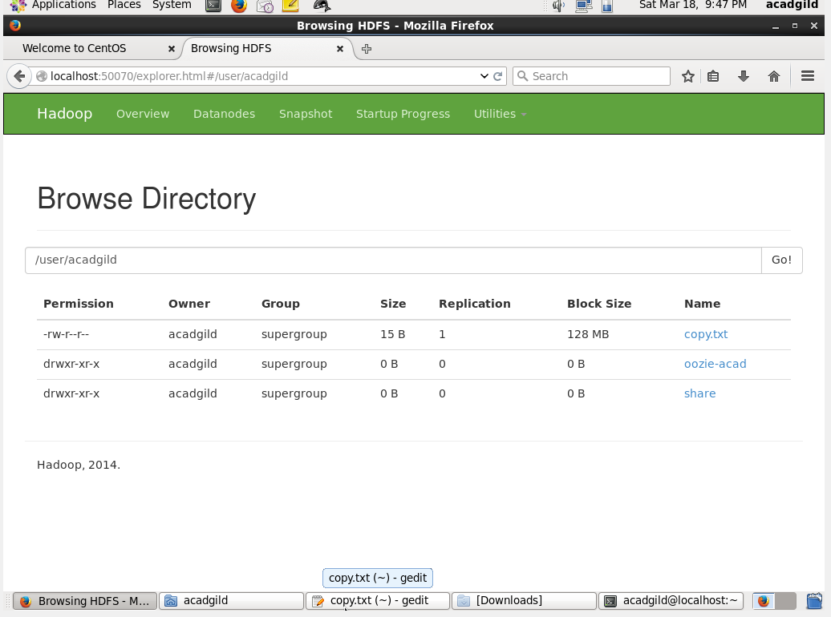

2.LIST COMMAND:

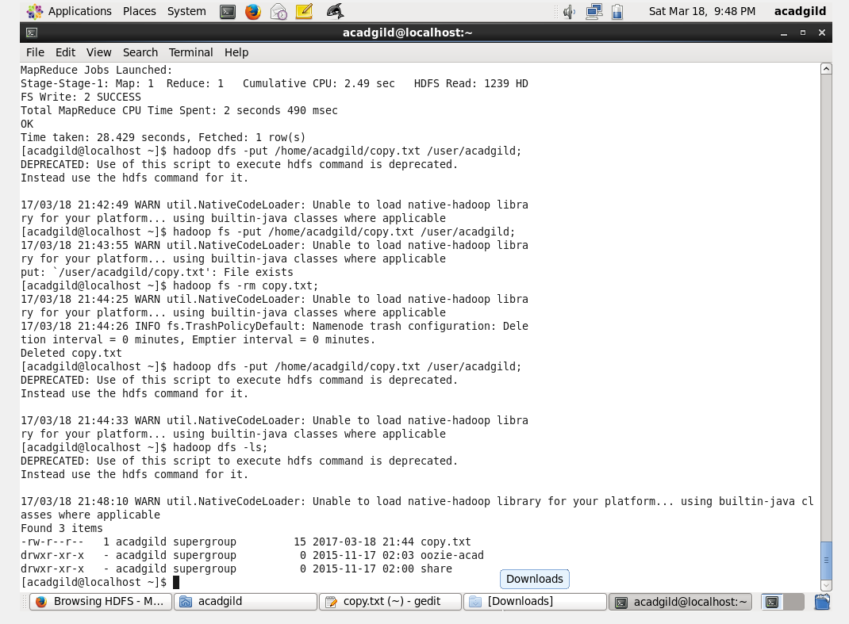

3.GET COMMAND:

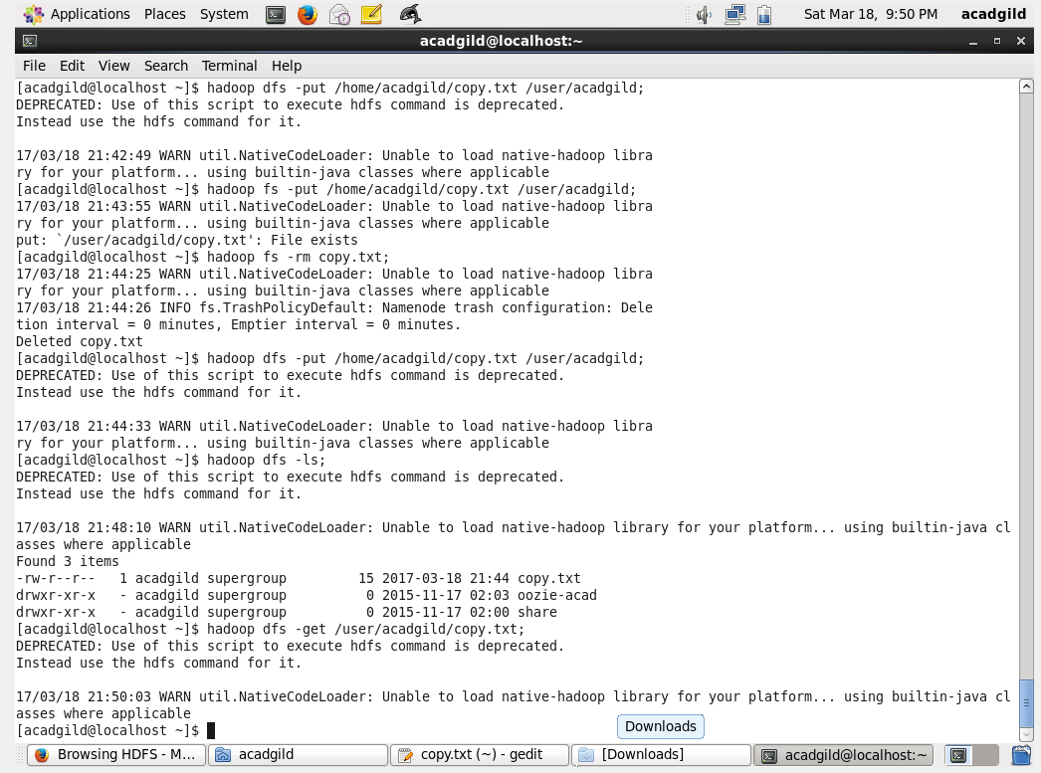

4. MAKE DIRECTORY COMMAND:

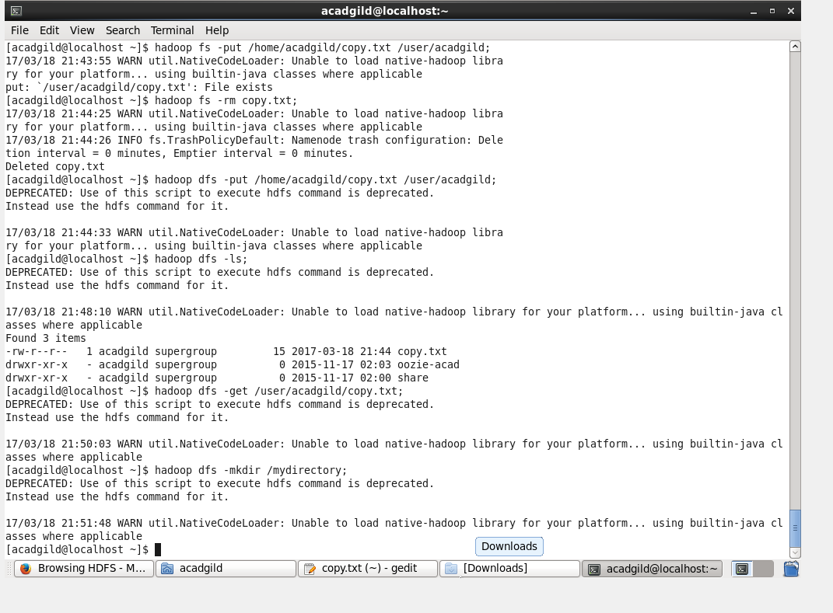

5.VIEW CONTENTS OF PARTICULAR FILE:

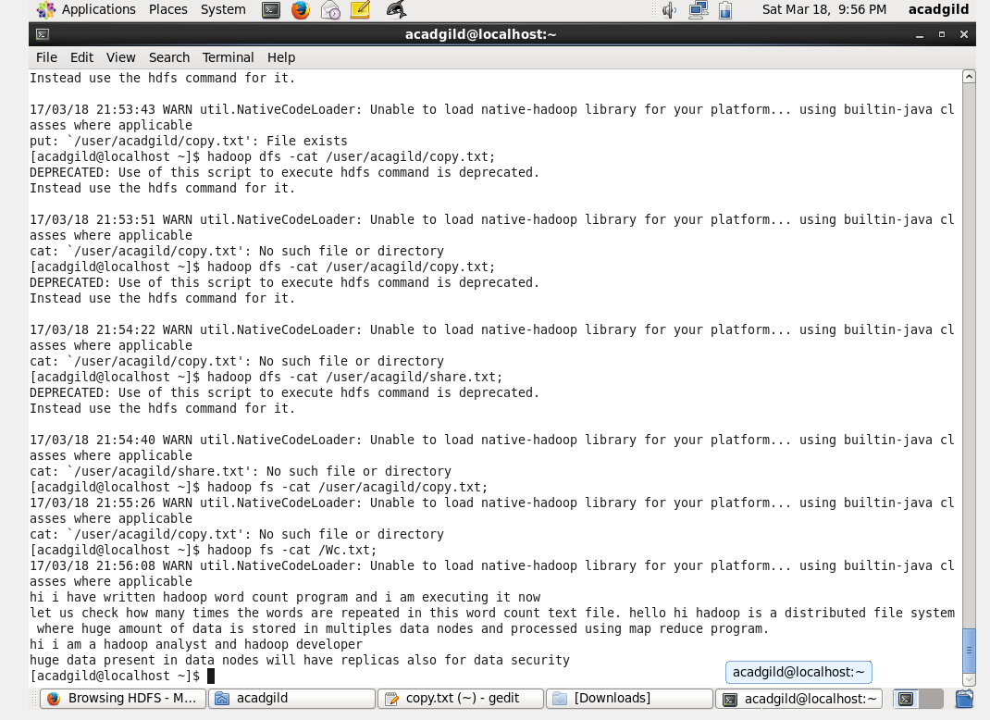

6.DUPLICATING A COMPLETE FILE INSIDE HDFS:

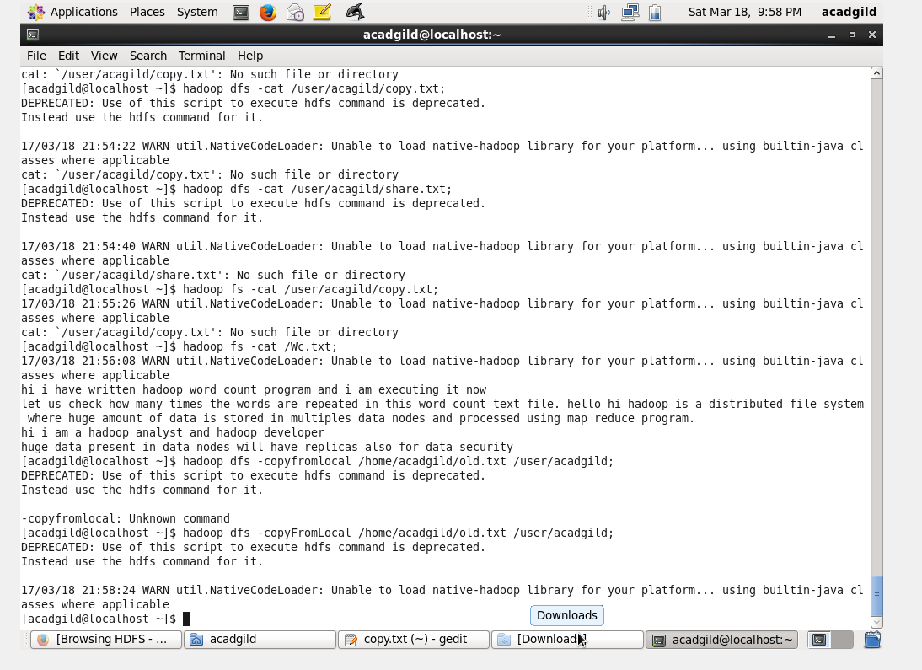

7.DUPLICATING A FILE FROM HDFS TO LOCAL SYSTEM:

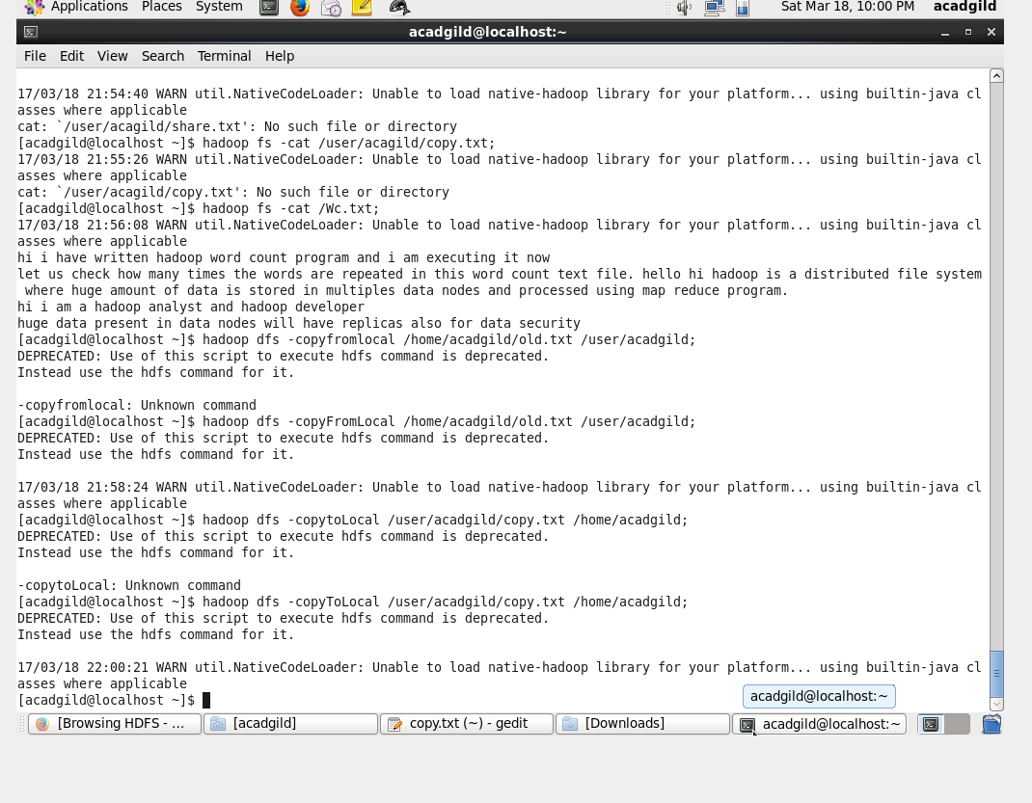

8.REMOVING THE FILE:

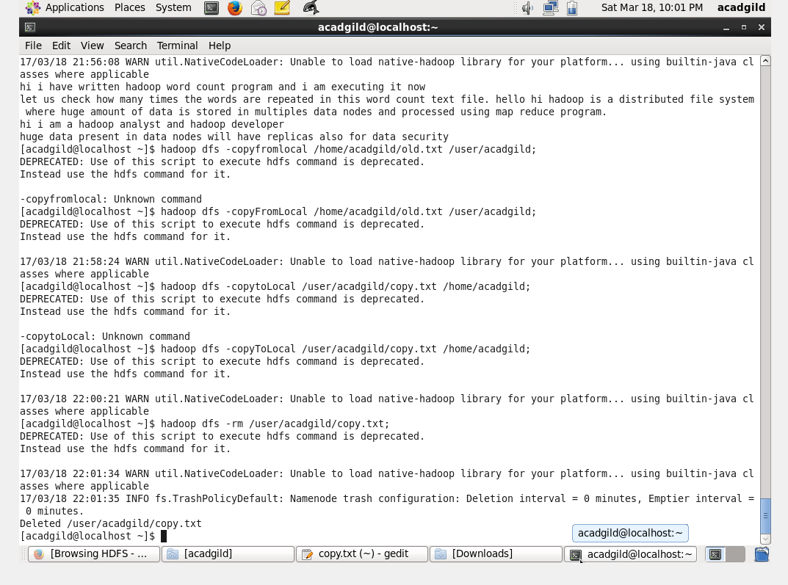

9.RUN A DFS FILE SYSTEM TO CHECK UTILITY:

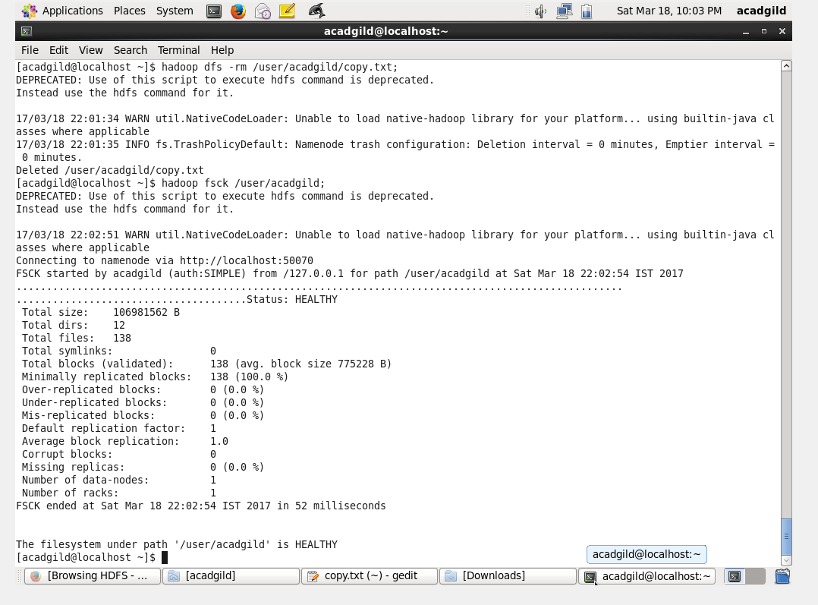

10.RUN A CLUSTER BALANCING UNIT:

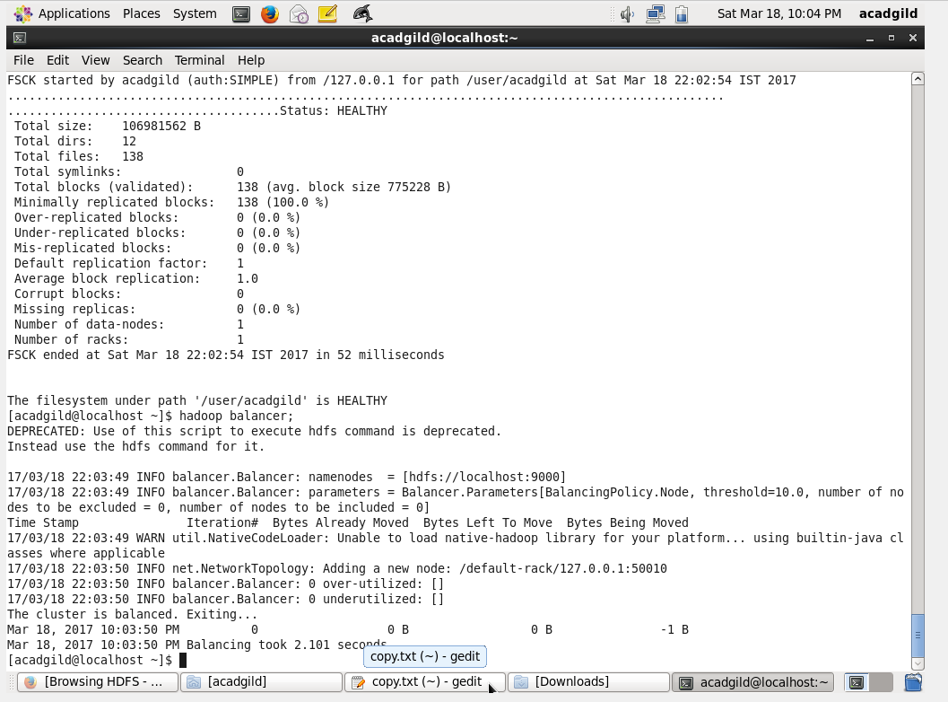

11.CHECK A DIRECTORY SPACE IN HDFS: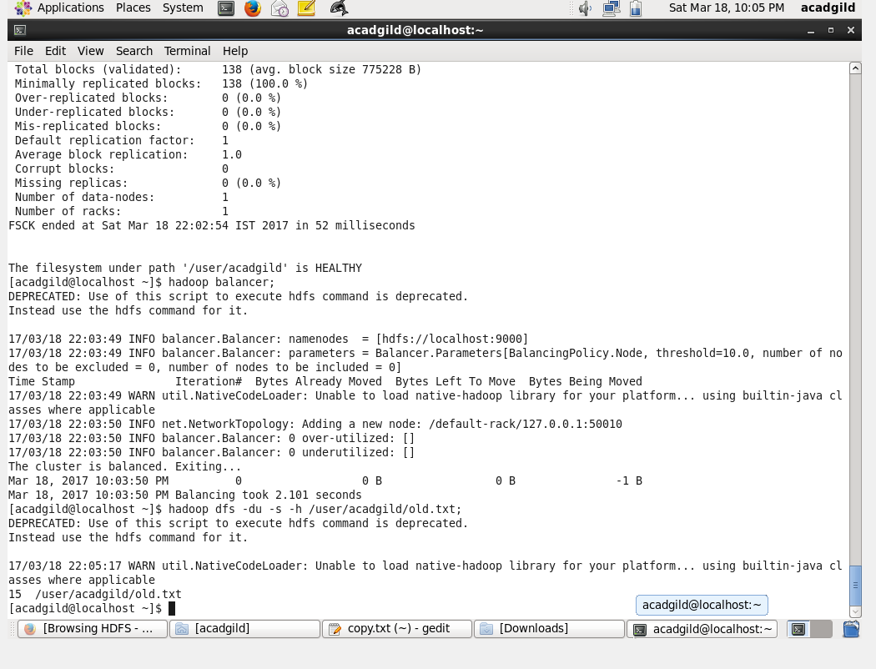

12.LIST ALL HADOOP FILE SYSTEM SHELL COMMANDS:

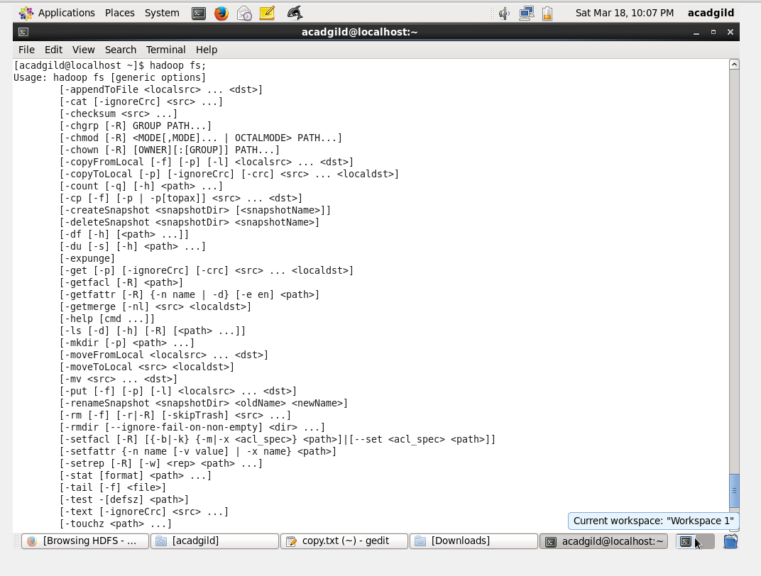

13.ASKING FOR HELP:

